The Radnor Arms
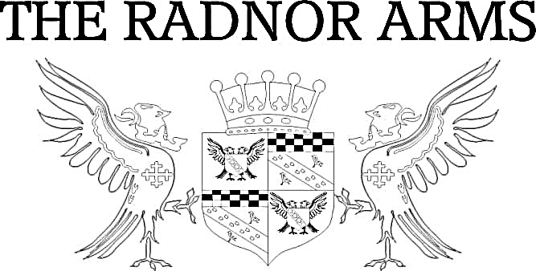
Antipasto
Marinated Olives £4.50 (V GF VE)
Halloumi Bites with chilli jam £5 (V GF)
Hummus with homemade Cajun spiced tortilla chips £4.50 (V VE)
Starters
Homemade Soup of the Day – 6.50 (V VE GF*)  Served with granary bread  Crispy Breaded Whitebait – £8 (DF)  With lemon & dill mayo  Homemade Thai Style Fishcakes -£ 8 (GF DF)  With salad & sweet chilli sauce | Vegetable spring Rolls – £8 (VE)  Served with wasabi mayo  Baked Camembert with Garlic & Rosemary - £9 (V)  With freshly baked baguette  Crispy Chilli Beef - £9 (DF)  Served with Salad
Main Course

Beer Battered Fresh Fish of the Day – £14 (DF)  Served with tartare sauce, steak cut chips & salad or peas  Pan-Fried Fillet of Seabass – £16 (GF DF)  Served patatas bravas & tenderstem  Hunter’s Chicken – £14 (GF DF*)  Grilled Chicken Breast topped with smoked bacon & cheddar. Choose from BBQ, creamy mushroom or peppercorn sauce. Served with steak cut chips & salad  Honey Roasted Wiltshire Ham & Eggs – £12 (GF DF)  Served with steak cut chips  Pan- Fried Chicken Breast with a mushroom, bacon & madeira cream sauce – £15 (GF)  Served on crushed new potatoes & tenderstem | Radnor Beef Burger – £14 (GF*)  Served in a pretzel bun with steak cut chips, salad & onion rings. Add bacon & cheddar, brie or stilton  Piri Piri Chicken Burger – £14 (GF*)  Served in a pretzel bun with chipotle mayo, steak cut chips, salad & onion rings  BBQ Pulled Pork Burger – £14 (GF*)  Served in a pretzel bun with Monterey jack, steak cut chips, salad & onion rings  Homemade Steak & Ale Pie – £14  Served with creamy mash, peas & gravy  Pork Belly stuffed with garlic & thyme – £16 (GF)  Served on mustard mash with tenderstem & cider jus

Vegetarian Salads

Beetroot & Quinoa Burger with salsa – £13 (VE)  Served in a pretzel bun with steak cut chips, salad & onion rings  Chickpea & Vegetable Tagine – £13 (VE*)  With apricot cous cous, tzatziki & grilled tortilla  Roasted Vegetable Lasagne – £13 (VE)  With salad & garlic bread  Homemade Macaroni Cheese – £13  Served with salad & garlic bread | Chicken & Bacon Caesar – £13 (GF*)  Served with or without anchovies  Parma Ham, Pear, Walnut & Stilton – £13 (GF)  With a French dressing  Roasted Mediterranean Vegetable, Olive, Red Onion & Halloumi Salad – £13 (GF V NF)  Served with a pesto dressing
Light Bites

Bacon, Brie & Cranberry (GF*) or Brie & Cranberry £8 (GF* V)
Coastal Cheddar & Branston £8 (V GF*)
Piri Piri Chicken, Chipotle Mayo & Sour Cream £8 (GF*)
Fish Goujon & Tartar Sauce £8
Mediterranean Vegetable, Pesto & Halloumi £8 (GF* NF)

All served on granary bread, freshly baked baguette or gluten free rolls

Coastal Cheddar Ploughman’s £10 (GF*)
Coastal Cheddar, Isle of Wight Blue, Book & Bucket Hardy’s & Shakespeare Ploughman’s £12 (GF*)
Ham & Coastal Cheddar Ploughman’s £12 (GF*)

All served with salad, pickles, apple, chutney & freshly baked baguette or gluten free roll

Sides
Steak Cut Chips – £3.50 (GF)  Cheesy Chips – £4.00 (GF)  Garlic Bread – £3.00  Cheesy Garlic Bread – £4.00 | Onion Rings – £3.00  Side Salad – £3.00 (GF)  Bread & Butter – £1.50  Sweet Potato Fries – £5.00 (GF)

For Children
(12 and under)

To drink – a choice of orange, blackcurrant or lime squash

Chicken Nuggets Wiltshire Ham & Egg (GF)
Beer Battered Fish of the Day Macaroni Cheese with garlic bread (V)

All served with chips or mash & beans or peas (excluding pasta dishes)

Dessert – 1 scoop of ice cream of your choice.

£7

Desserts

Black forest Gateaux £6.50
Sticky Toffee Pudding £6.50
Raspberry Eton Mess Cheesecake £6.50
Mars Bar Cheesecake £6.50
Blackberry & Apple Sponge £6.50

Ice-cream (GF): Vanilla, chocolate, strawberry, toffee crunch, salted caramel, mint choc, coffee mocha
Sorbet (GF DF): Lemon, blackcurrant, blood orange, coconut & lime £4.00

Portions for smaller appetites are available, please ask a member of staff.

If you have any special dietary requirements, please inform a member of staff so we can advise you what would be suitable.

Terms & Conditions:
All prices are inclusive of VAT at current rate of 20%. All weights are approximate prior to cooking. Metric equivalent 16oz =1lb = 454g. All menu items are subject to availability. Please note, our fish and meat products may contain bones. All products may contain nut or nut derivatives. Menu descriptions may not list full dish content. If you have any queries please do not hesitate to ask a member of the team. Yu

