The Radnor Arms
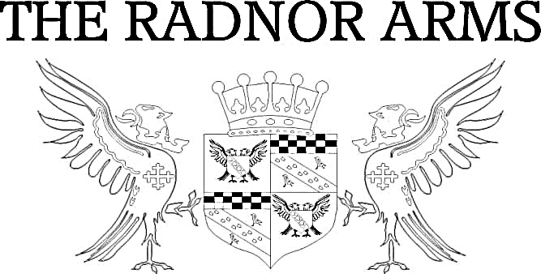
Pub Lunch

Coastal Cheddar Ploughman’s – 9.00

Mixed Cheese Ploughman’s - 11.00
A selection of Cornish Yarg, Book & Bucket Brie, Coastal Cheddar & Isle of White Blue

Wiltshire Ham & Coastal Cheddar Ploughman’s – 12.00

All served with salad, pickles, chutney & freshly baked baguette or gluten free roll

3-2-1 – 8.50
3 rashers of bacon, 2 eggs & a portion of hand cut chips

4-3-2-1 – 9.50
1 sausage, 2 eggs, 3 rashers of bacon & a portion of hand cut chips

Jacket Potatoes
All served with side salad £8.00

Mediterranean Vegetables, Pesto & Halloumi  Tuna Mayo, Red Onion & Cheddar  Bacon & Cheddar | Cajun Chicken topped with cheddar  Cheddar Cheese & Beans  Prawn & Marie Rose Sauce

Sandwiches, Baguettes or Gluten Free Rolls
All served with side salad & hand cut chips £8.00

Mature Cheddar Cheese & Red Onion Chutney  Mediterranean Vegetables, Pesto & Halloumi  Cajun Chicken, Guacamole & Rocket  Prawn, Rocket & Marie Rose Sauce | Tuna Mayo & Red Onion  Honey Roasted Wiltshire Ham  Bacon, Brie & Cranberry  Brie & Cranberry

Terms & Conditions:
All prices are inclusive of VAT at current rate of 20%. All weights are approximate prior to cooking. Metric equivalent 16oz =1lb = 454g. All menu items are subject to availability. Please note, our fish and meat products may contain bones. All products may contain nut or nut derivatives. Menu descriptions may not list full dish content. If you have any queries please do not hesitate to ask a member of the team.

