The Radnor Arms
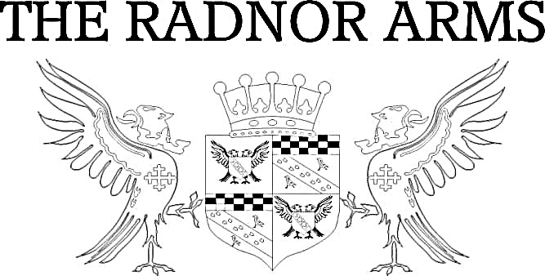
Antipasto
Marinated Olives £4.50 (V GF VE)
Halloumi Bites with chilli jam £5 (V GF)
Hummus with homemade Cajun spiced tortilla chips £4.50 (V VE)
Starters
Creamy Mushroom Soup – £6.50 (V GF)  Served with malted bread  Crispy Breaded Whitebait – £8 (DF)  With lemon & dill mayo  Sautéed King Prawns in garlic butter -£9 (GF*)  With fresh bread | Vegetable Gyoza with soy sauce – £7 (VE)  Duck Gyoza with hoisin sauce - £7  Oven Baked Garlic & Rosemary Camembert - £9 (V GF*)  Served with dipping bread & red onion chutney  Duck Liver & Orange Pate - £8 (GF*)  Served with toast & chutney
Main Course

Hunter’s Chicken – £14 (GF DF*)  Grilled chicken breast topped with smoked bacon & cheddar. Choose from BBQ, creamy mushroom or peppercorn sauce. Served with steak cut chips & salad  Honey Roasted Wiltshire Ham & Eggs – £12 (GF DF)  Served with steak cut chips  Thai Green Chicken Curry – £15 (GF)  Served with rice  Parma Ham, Pear, Walnut & Stilton Salad - £13 (GF)  With a French dressing  Roasted Mediterranean Vegetable, Olive, Red Onion & Halloumi Salad – £13 (GF V NF*)  Served with a pesto dressing | Radnor Beef Burger – £14 (GF*)  Served in a pretzel bun with steak cut chips, salad & onion rings. Add bacon & cheddar, brie or stilton  Sriracha Chicken Burger – £14 (GF*)  Served in a pretzel bun with mayo, steak cut chips, salad & onion rings  Homemade Steak & Ale Pie - £14  Served with creamy mash, peas & gravy  Belly of Pork with black pudding medallions- £16  Served on creamy mash with a cider & mustard sauce  Red Wine Braised Brisket of Beef – £16 (GF*)  Served with vegetables & dauphinoise potatoes

Vegetarian Fresh Fish

Beetroot & Quinoa Burger with salsa – £13 (VE)  Served in a pretzel bun with steak cut chips, salad & onion rings  Butternut Squash, Chilli, Feta & Pumpkin Seed Roulade – £15 (V)  With a new potato, spinach & pea medley  Roasted Vegetable Lasagne – £13 (VE*)  With salad & garlic bread  Homemade Macaroni Cheese – £13 (V)  Served with salad & garlic bread | Beer Battered Fillet of Cod – £14 (DF)  Served with tartare sauce, steak cut chips & salad, peas  or mushy peas  Clam, Mussel, Crab & King Prawn Risotto - £16 (GF)  Topped with langoustine & fresh chilli oil  Pan-Fried Monkfish Tail wrapped in Parma Ham with spinach – £17 (GF )  Served with dauphinoise potatoes & an Atlantic prawn beurre blanc

Sandwiches or Baguettes

All served on malted bread, freshly baked baguette or gluten free rolls with chips & salad

Mediterranean Vegetable, Pesto & Halloumi £8 (GF* NF*)
Bacon, Brie & Cranberry (GF*) or Brie & Cranberry £8 (GF* V)
Coastal Cheddar & Branston £8 (V GF*)
Sriracha Chicken & Mayo £8 (GF*)
Fish Goujon & Tartar Sauce £8
Atlantic Prawn & Mayo £8

Ploughman’s

All served with salad, pickles, apple, chutney & freshly baked baguette or gluten free roll

Coastal & Black Cow Cheddar Ploughman’s £10 (GF*)
Black Cow Cheddar, Isle of Wight Blue, Book & Bucket Shakespeare & Boilie Goats Cheese Pearls Ploughman’s £12 (GF*)
Ham & Coastal Cheddar Ploughman’s £12 (GF*)

Sides
Steak Cut Chips – £3.50 (GF)  Cheesy Chips – £4.00 (GF)  Garlic Bread – £3.00  Cheesy Garlic Bread – £4.00 | Onion Rings – £3.00  Side Salad – £3.00 (GF)  Bread & Butter – £1.50  Sweet Potato Fries – £5.00 (GF)

For Children
(12 and under)

To drink – a choice of orange, blackcurrant or lime squash

Chicken Nuggets Pork Sausages Wiltshire Ham & Egg (GF)
Beer Battered Fish of the Day Macaroni Cheese with garlic bread (V)

All served with chips or mash & beans or peas (excluding pasta dishes)

Desserts

Lemon Tart £6.50
Sticky Toffee Pudding £6.50
Warm Chocolate Brownie £6.50
Forrest Fruits Cheesecake £6.50
Lemon Meringue Pie £6.50
Banoffee Pie £6.50
All served with custard, cream or ice cream

Ice-cream (GF): Vanilla, chocolate, strawberry, toffee crunch, salted caramel, mint choc, honey & fig
Sorbet (GF DF): Lemon, blackcurrant or blood orange
1 scoop - £1.80 2 scoops - £3.50 3 scoops - £4

If you have any special dietary requirements, please inform a member of staff so we can advise you what would be suitable.

Terms & Conditions: All prices are inclusive of VAT at current rate of 20%. All weights are approximate prior to cooking. Metric equivalent 16oz =1lb = 454g. All menu items are subject to availability. Please note, our fish and meat products may contain bones. All products may contain nut or nut derivatives. Menu descriptions may not list full dish content. If you have any queries please do not hesitate to ask a member of the team.

